**Fresh Fade**

**Atlanta, Co**

|  |  |  |
| --- | --- | --- |
| **Date** | **Author** | **Homework #** |
| **2/25/20** | **Amir** | **1** |

Table of Contents

Section I: Project Description 3

Section II: Use Cases 4

Barber Creating a Profile: 4

Customer Creating a Profile: 4

Customer Posting a Review with Photos: 4

Barber relocating to a new state: 5

Customer Requesting In-House Service 5

Section III: Business Rules 6

Barber Rules: 6

Customer Rules: 6

Section IV: Detailed List of Main Entities, Attributes and Keys 7

Section V: Entity Relationship Diagram (ERD) 9

Section VI: Testing Table 10

# Section I: Project Description

Fresh Fade is a branch of a bigger Company named Atlanta, Co who owns different brands and offers the Services to the whole America. One of the services of this company is called Fresh Fade. Atlanta hires the managers and appoints them to different states to control the employees in that state, and allows freelancing interested peopled to join the company to work. Fresh Fade is here to help people get the desire haircut as fast as possible in their location. We allow barbers to sign up into our website and become part of our company and make a profile for themselves. Fresh Fade provides two options for barbers. The barber could travel for work or work at our shops all around the states. The other side of this project would be the customer who is looking for a haircut appointment. The customer needs to make a profile also to be able to set an appointment from the available barbers. After the appointment is done customer can post a picture or a review for the specific barber. The reviews would show up on the barber’s profile page to differentiate between the barbers. Fresh Fade also hires hair specialist and other services.

# Section II: Use Cases

## Barber Creating a Profile:

**Juan** has moved out from Los Angeles to San Francisco. **Juan** had a great reputation out in Los Angeles, and now is trying to build up clients after moving out to the city. **Juan** goes to different barber shops in the city to get idea of how everything works. During one of his visits he was introduced to a website called FreshFade to help him build clients and get some work. He visits the website the next day as his interest has peeked. **Juan** decides to take the next step and create a free profile page registering as a new barber to be able to find clients looking for a haircut in his district. **Juan** has finished signing up as a new barber to work at one of our shop in the downtown and now he can also post pictures of his work and update his location of work to start getting clients.

## Customer Creating a Profile:

**John** is supposed to go to a birthday party Friday night. He’s regular barber is not available to give him a fresh fade. So he ends up searching online for available barbers in his location. He comes across the website FreshFade. He reads the description of the website and without blinking an eye he takes the next step to creating a profile. He ends up creating a profile and gets redirected to the booking page to find available barbers. Depending on the location and the time requested **John** is able to find a good barber with good reviews in an hour from signing up.

## Customer Posting a Review with Photos:

**Carlos** has just finished paying the barber **Juan** and is leaving the store. **Juan** marks **Carlos** visit on the website completed. **Carlos** receives an email asking him if he likes to post a review for **Juan** the barber. **Carlos** was satisfied by the haircut he got. He clicks on the link and gets redirected to the review page for the **Juan**. **Carlos** takes a picture of his fresh haircut also and attaches it to the review he posted for the barber **Juan** so other customers can see before deciding.

## Barber relocating to a new state:

**Andy** loves to move around the states every now and then to get an experience of different cultures. Andy is already a member of Fresh Fade. The company helps the barbers to relocate but **Andy** was not aware of that. After he moved to New York from San Diego he tried to sign up on Fresh Fade again. He received an error after he input his information for the process of signing up. The email is already taken. Andy called the company support desk and was informed about the proper way applying through the company for relocation and getting support.

## Customer Requesting In-House Service

**Nick** has Saturday and Sunday off the upcoming weekend. He wants to receive a haircut Saturday morning in his house instead of driving out. He comes back to the website to search for available barbers on Saturday morning. He chooses the filter in-house instead of the shop refreshes the search. After going through the list he finds his desired barber **Rocky.** After reading the reviews he makes an appointment with her for Saturday morning at 9am. **Rocky** also included in her profile that she would be bring all the essential equipment for the work so **Nick** don’t need to worry about.

# Section III: Business Rules

## Barber Rules:

1. Barber can have only one account.
2. Barber can have multiple bookings.
3. Barber can work only in one city.
4. Barber can offer multiple services.
5. Barber can post pictures of his/her work.
6. Barber can modify his schedule.
7. Barber can change location.
8. Barber can have one direct deposit account for payday.
9. Payments can be supervised by the company managers.
10. Stores have one and only one manager.
11. Managers are allowed to supervise each other.

## Customer Rules:

1. Customer can only have one account.
2. Customer can post a review for a Barber.
3. Customer can make one or many appointments.
4. Customer can have multiple cards on account.

# Section IV: Detailed List of Main Entities, Attributes and Keys

1. **Barber Table:**

* Email: Primary Key
* Name: composite
* ServiceType:

1. **DirectDeposit Table:**

* Id: Primary Key
* BarberEmail: Foreign Key
* AccountNumber:

1. **Payment Table:**

* id: Primary Key
* BarberEmail: Foreign Key
* UserEmail: Foreign Key
* cardId: Foreign Key
* amount:
* date:

1. **Services Table:**

* BarberEmail: Foreign Key
* Service Type:
* locationId: Foreign Key

1. **Location Table:**

* Id: Primary Key
* barberEmail: Foreign Key
* managerId: Foreign Key
* State:

1. **Manager Table:**

* Id: Primary Key
* Name:

1. **User Table:**

* Email: Primary Key
* Name:
* ProfileLocation:

1. **UserCards Table:**

* Id: Primary Key
* UserEmail: Foreign Key
* CardNumber:
* MonthExp:
* CVV:

1. **Appointment Table:**

* UserEmail: Foreign Key
* bookingId: Foreign Key
* date

1. **Booking Table:**

* id: Primary Key
* BarberEmail: Foreign Key
* UserEmail: Foreign Key
* Date:
* Location:
* ServiceType:

1. **Review Table:**

* BarberEmail: ForeignKey
* UserEmail: ForeignKey
* ReviewText:
* Stars:

1. **Direct Deposit Table:**

* Id: Primary Key
* BarberEmail: Foreign Key
* AccountNumber:

1. **Pay Check Table:**

* Id: Primary Key
* DepositId: Foreign Key
* Date:
* totalAmount: Derived

# Section V: Entity Relationship Diagram (ERD)

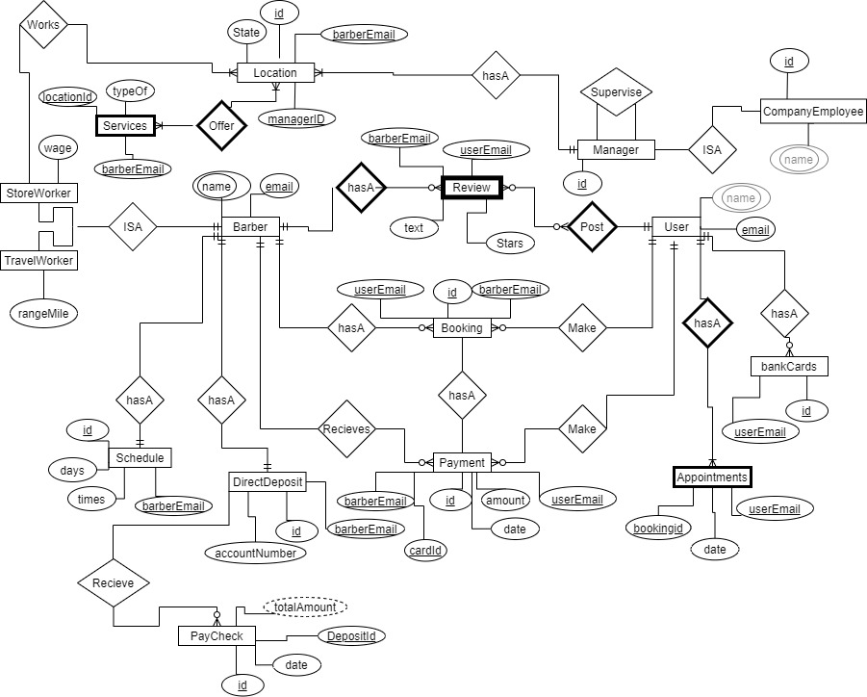

## Section VI: Testing Table

|  |  |  |  |  |  |  |
| --- | --- | --- | --- | --- | --- | --- |
| **Rule** | **Entity A** | **Relation** | **Entity B** | **Cardinality** | **Pass/Fail** | **Error Description** |
| 1 | Barber | HasA | Booking | 1-to-1 | Fail | Barber Can have multiple Bookings 🡺 1-to-N |
| 2 | Barber | HasA | Review | 1-to-N | Pass |  |
| 3 | Barber | Recieves | Payment | 1-to-N | Pass |  |
| 4 | Barber | HasA | DirectDeposit | 1-to-N | Fail | Barber can have only one DirectDeposit 🡺 1-to-1 |
| 5 | Barber | HasA | Schedule | 1-to-1 | Pass |  |
| 6 | Barber | ISA-Works | Location | 1-to-M | Pass |  |
| 7 | Location | Offer | Services | M-to-M | Pass |  |
| 8 | Location | HasA | Manager | M-to-1 | Pass |  |
| 9 | User | HasA | BankCards | 1-to-1 | Fail | User can have multiple cards to pay or not 🡺 1-to-N |
| 10 | User | HasA | Appointments | 1-to-N | Pass |  |
| 11 | User | HasA | Booking | 1-to-N | Pass |  |
| 12 | User | Post | Review | 1-to-N | Pass |  |
| 13 | User | Make | Payment | 1-to-N | Pass |  |